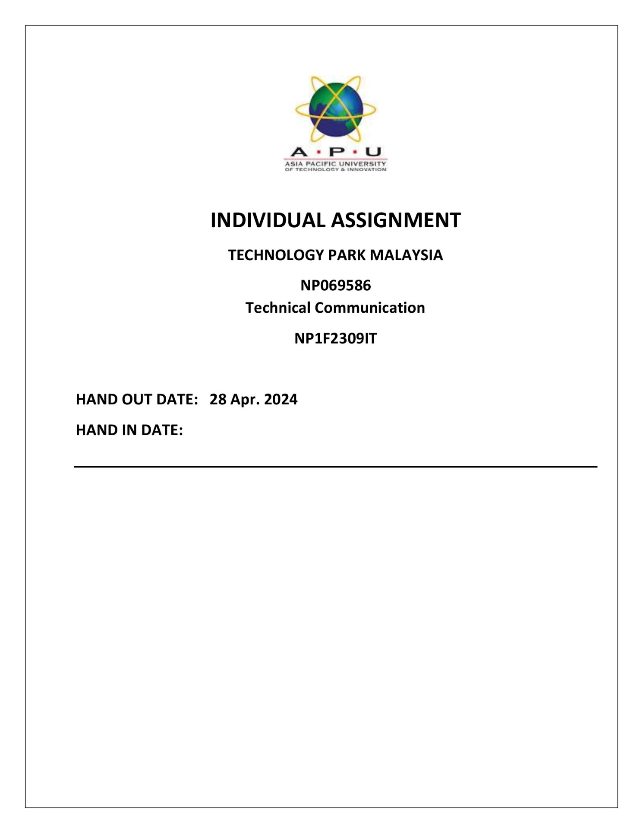

**Acknowledgement**

With great gratitude, I would like to thank Asia Pacific University and Ms. Saya Joshi for providing me with this design. In addition to honing my understanding of academic concepts, this work has sharpened my practical skills and prepared me for future professional challenges. This activity not only helped me better understand academic issues, but it also improved my practical skills and prepared me for future professional challenges. I've been given a fantastic opportunity to implement what I've learnt in class.   
I am appreciative for Ms. Saya Joshi's advice and encouragement.

Thank you

Atul Dhital



03th May 2024

MICROSOFT IT Pvt. Ltd

[microsoftpvt@gmail.com](mailto:microsoftpvt@gmail.com)

MICROSOFT IT Pvt. Ltd. is a Nepal- grounded company that has been erecting software and transubstantiating technology for the once 11 times, aiding businesses in establishing a digital presence. The following are the stylish companies for which we give specialized support

1. Krishi Bikash bank
2. Nico Insurance
3. Kathmandu codes
4. LBEF council
5. Nepal Bank LTD.

I'm writing on behalf of MICROSOFT IT Pvt. Ltd. to present a collaboration opportunity with The Elevate Official. Enclosed is a thorough offer highlighting innovative IT results tailored to your company's individual needs and driving digital transformation.

MICROSOFT IT Pvt.Ltd. is dedicated to delivering modern technological results that improve functional effectiveness, enhance the customer experience, and drive company success. Our determination and dedication to quality make us the ideal strategic partner for addressing The Elevate Official's challenges and seizing possibilities.

We are excited to discuss our offer more and see how we can help The Elevate Official succeed. Feel free to contact me at 9869414179 ordhitalatul4gmail.

Thank you for considering MICROSOFT IT Pvt. Ltd. for this collaboration.  
Sincerely  
Atul Dhital  
Project Manager  
MICROSOFT IT Pvt. Ltd

Table of Contents

Introduction 5

Problem identification 1

The challenges of the development 1

Objects of this design 2

Plans To Execute the Project 3

Benefits of Following These Stylish 3

Qualifications of MICROSOFT IT PVT.Ltd 5

BUDGET BREAKDOWN 6

Software Layout 7

Here is flow of production system 7

Flow if digital marketing system 7

CONCLUSION 8

References 9

Letter of recommendation 11

Journal of the experience 13

PROGRESS MEETINGS HELD 14

# Introduction

MICROSOFT IT Pvt. Ltd. is a Nepalese multinational company that has been rising software and hardware technology company, aiding businesses in establishing a digital presence. MICROSOFT IT Pvt. Ltd. Not only focus on software development, but there is also a Nepal-based global hardware assembly company that provides top-notch service to companies that require both software and hardware component support.

1. Krishi Bikash bank
2. Nico Insurance
3. Kathmandu codes
4. Nepal Army
5. Dhulikhel Hospital
6. LBEF council
7. Nepal Bank LTD.

Now, we want to support Elevate Official, a top food product establishment positioned in Nepal. We'd like to submit our specialized support purpose to the Elevate functionary.

The increase in product at The Elevate Official means that IT support conditions may be fulfilled more efficiently and bring- effectively. Sandra Davison- Wilson, The Elevate's Vice President of Administration and Finance, asked IT Services operation to examine their areas' support conditions and current service delivery plans. The purpose of this document is to recommend that advanced- position officers develop an IT support model that standardizes the support structure, improves support request operation, and defines morals and protocols for everyone to follow. The new models will also cover coffers, places, liabilities, prospects, services, and staff reporting, among other company- related themes.

The two proposed backing models are a mix of delivery mechanisms designed to meet the Elevate functionary's criteria.

# Problem identification

The Elevate Official, which is well-known for its dedication to produce quality food in Nepal. a well define work flow and well develop system is required to fulfilled the requirement of company work. Now we want to provide all the It related support towards elevate officials that include production related system digital marketing support account related systems or many more that is required for day-to-day task of elevate official.

Workflow inefficiencies can severely restrict content management, resulting in delays and increased expenses (ButterCMS).

Elevate officers admit that boosted specialized backing is essential to support product expansion while also furnishing respectable client support services.

## The challenges of the development

1. Relating backing sources for IT;
2. Aligning mortal coffers with elevate sanctioned conditions;
3. Managing physical structure growth in Grand Chute;
4. Addressing the oneness of technology that supports elevate sanctioned growth;
5. enforcing a mixed support strategy;
6. Maintaining heritage systems and mortal coffers to support guests.
7. Elevate Official's adding operations lacks a defined IT support frame.
8. Support request administration is hamstrung, and norms and protocols are unclear.
9. Challenges in relating and carrying backing for IT enterprise.
10. It's delicate to align mortal coffers with Elevate Official's conditions.
11. shy operation of physical structure expansion.
12. Issues in addressing the oneness of the technology supporting Elevate Official's growth.
13. The need to establish a diversified support plan.
14. Challenges in maintaining old systems and meeting consumer demands.
15. Poor performance of university operations distributed over the internet, performing in client unhappiness and lower productivity.

A manufacturing system converts input into output. Meaning, it's the processes that create a product out of whatever components are required to make it a reality (Luleå University of Technology, 2022)

# Objects of this design

1. Regularize Support Structure produce a standardized IT support approach that's harmonious with Elevate Official's growth and functional conditions.

2. Ameliorate Support Request Operation Make support request operation styles more effective and effective to ensure that IT issues are resolved on time.

3. Define morals and Protocols produce clear morals, protocols, and rules for all stakeholders to cleave to in terms of IT support, places, duties, and reporting.

4. Allocate Funding Sources detect and gain applicable backing sources for IT enterprise and structure advancements demanded to support Elevate Official's growth.

5. Align Human coffers ensure that mortal coffers are in line with Elevate Official's requirements, including staffing situations, chops, and moxie.

6. Manage structure Growth To support expanding operations, strategically manage physical structure growth in Grand Rapids and satellite premises.

7. Address Technology Oneness produce results to address the specific technology conditions that enable Elevate Official's growth line.

8. Apply a Mixed Support Strategy Combine different support models (CPTS, Bobby, and KCAD) to deliver complete and technical support services grounded on specific conditions.

9. Maintain Legacy Systems ensure the durability and support of heritage systems, as well as the mortal coffers needed to efficiently satisfy client service prospects.

10. Ameliorate operation Delivery Performance Ameliorate the performance of university operations supplied via the internet to increase client happiness, productivity, and retention.

# Plans To Execute the Project

Information Technology Support Associations far and wide are always challenged to Accomplish more with lower and help their businesses prosper. likewise, our workers and guests anticipate us to define and ameliorate places and liabilities, programs, processes, and procedures to give structure and guidance in their work. We also need to communicate with our guests about what we can and can not do, as well as what they may do to help.

IT Service Management (ITSM) is a process- grounded strategy that aims to match the delivery of information technology (IT) services with organizational pretensions while fastening on client benefits. IT Service Management (ITSM) is a process- grounded strategy that aims to match the delivery of information technology (IT) services with organizational pretensions while fastening on client benefits.

## Benefits of Following These Stylish

1. regularize the Support Structure Conduct a complete review of Elevate Official's current IT support frame. produce standardized procedures, protocols, and guidelines for IT support tasks. produce a centralized system to manage support requests and track judgments.
2. Ameliorate support request operation produce a marking system to log, prioritize, and track support requests. Establish defined escalation pathways and response time targets for colorful feathers of requests. Train IT support professionals on how to handle and resolve requests efficiently.
3. Define morals and protocols produce a thorough IT support policy document that defines places, liabilities, and communication styles. Conduct training sessions and shops to insure that all stakeholders understand and follow the specified rules and regulations.
4. Allocate backing sources unite with Elevate Official's fiscal and operation departments to determine budget allocations for IT systems. probe prospective collaborations or backing openings with technology suppliers or government agencies.
5. Align mortal coffers Conduct a chops gap study to determine training and reclamation conditions. produce career paths and skill development programs for IT professionals to meet Elevate Official's changing demands.
6. Manage structure growth Conduct a capacity planning trouble to prepare for and handle structure growth. apply scalable results and technologies to accommodate growth without immolating performance.
7. Address Technology Uniqueness unite with Elevate Official's technology stakeholders to understand their specific conditions. Customize or produce IT results that address Elevate Official's specific technology difficulties.
8. Apply a mixed support strategy Integrate the CPTS, Bobby, and KCAD support models to form a comprehensive frame. Assign places and duties within each support model, and produce effective communication routes.
9. Maintain heritage systems apply regular conservation schedules and upgrades for heritage systems. Train IT labor force in heritage system support and troubleshooting strategies to insure nonstop functionality.
10. Ameliorate operation delivery performance Conduct performance checkups on university operations to discover backups and openings for enhancement. apply optimization results, similar as content delivery networks (CDNs) or caching systems, to ameliorate operation speed and responsibility.

Elevate Official will be suitable to efficiently handle its IT support difficulties, streamline operations, ameliorate client satisfaction, and negotiate its growth pretensions through the perpetration of this thorough plan.

# Qualifications of MICROSOFT IT PVT.Ltd

MICROSOFT IT Pvt. Ltd. provides a wealth of moxie, bents, and credentials, allowing us to successfully carry out Elevate Official's proposed IT support design. Our association and crucial labor force have the academic and professional credentials necessary to establish credibility and give outstanding issues. We bring the following qualifications to the design.

1. Establishment Experience Over 11 times of moxie with software development, technology metamorphosis, and IT support services. Proven track record of effectively enforcing IT systems across multiple diligence, including banking, insurance, and education.

2. Key Personnel Expertise Our staff includes good IT specialists that have expansive knowledge and hands- on moxie in IT support, structure operation, and operation performance optimization. Academic credentials include degrees and instruments in computer wisdom, information technology, design operation, and other subjects.

3. Past Project Experience analogous IT support enterprise have been successfully completed for enterprises of varied sizes and complexity. Formalized support structures, bettered request operation systems, and streamlined IT structure bettered performance and trust ability.

4. Credibility and trust Our company's character for furnishing high- quality services while fulfilling design deadlines on time and under budget. customer witnesses and references attest to our professionalism, knowledge, and commitment to excellence.

5. Nonstop literacy and Development Commitment to nonstop training, instruments, and staying current on assiduity developments and stylish practices.

Participation in professional forums, shops, and conferences to constantly ameliorate chops and knowledge.

Our qualifications demonstrate our readiness and moxie to take on the IT support design for Elevate Official, assuring a successful and effective collaboration that fosters commercial growth and success.

# BUDGET BREAKDOWN

To efficiently apply the intended, elevate sanctioned IT support design, a fiscal estimate must be developed. The budget is divided into sub-dependencies, which list needed coffers and give awaited quantities for each element.

1. structure & tackle
   1. Purchase of waiters, networking outfit, and tackle factors$ 30,000
   2. Installation and configuration of structure$ 10,000
   3. License freights for software and tools$ 15,000
2. Software Development and Customization
   1. Development and customization of IT support software$ 50,000
   2. Integration with being systems and operations$ 20,000
   3. Testing and quality assurance$ 15,000
3. Human coffers
   1. design operation and collaboration$ 25,000
   2. b. IT support staff hires and benefits$ 80,000
   3. c. Training and professional development$ 10,000
4. Consultancy and Outsourcing
   1. External consultancy freights for technical moxie$ 15,000
   2. b. Outsourcing of specific tasks or services$ 20,000
5. Eclectic Charges
6. Trip and accommodation for on- point visits$ 5,000
7. Contingency fund for unlooked-for charges$ 10,000

**Total Budget Estimate**: $ 325,000

This budget for only the first phase of project. Where we implement the production system and digital marketing system for elevate official.

**Note**: *The below budget estimate is grounded on a thorough examination of the design's conditions, which include structure demands, software development, mortal coffers, consulting, and eclectic charges. It displays a realistic budget that addresses all critical factors of Elevate Official's IT support design while leaving room for contingencies and variations throughout the perpetration phase.*

# Software Layout

## Here is flow of production system

## Flow if digital marketing system

# CONCLUSION

MICROSOFT IT Pvt. Ltd. is well- equipped and ready to take on the Elevate Official IT support design, owing to our considerable experience, capability, and track record in software development and technology. Our proposed IT support model addresses the following challenges homogenizing support structures, perfecting request operation, defining morals and protocols, allocating backing sources, aligning mortal coffers, managing structure growth, addressing technology oneness, enforcing a mixed support strategy, maintaining heritage systems, and perfecting operation delivery performance.

The thorough budget estimate offered reflects a realistic assessment of the coffers and charges demanded to complete the design effectively while maintaining effectiveness, quality, and punctuality. We're devoted to delivering great issues and working directly with Elevate Official to meet its growth pretensions and ameliorate functional effectiveness by furnishing robust IT support results.

We're agitated about the occasion to work and contribute to Elevate Official's success by fostering invention, productivity, and client happiness in moment's ever- changing digital geography.

Thank you for considering MICROSOFT ITPvt.Ltd. as a dependable IT mate.

Contact Information:

Name: Atul Dhital  
Project Manager  
+977 9167828293

# References

(n.d.). Retrieved from ButterCMS: https://buttercms.com/blog/enterprise-content-management-challenges/

*Challenges in News Segmentation and How to Overcome The.* (2022). Retrieved from Neuroscientia: https://neuroscientia.com/news-segmentation-challenges/

*How to Manage Multiple Content Types with CMS.* (n.d.). Retrieved from Contentful : https://www.contentful.com/r/knowledgebase/managing-multiple-content-types/

*ButterCMS.* (n.d.). Retrieved from Why Workflow Management is Critical for CMS.: https://buttercms.com/blog/why-workflow-management-is-critical-for-cms

*Ensuring CMS Performance and Reliability.* (2021). Retrieved from CMSWire: https://www.cmswire.com/digital-experience/ensuring-cms-performance-and-reliability/

*Enterprise Content Management Challenges and How to Avoid Them.* (n.d.). Retrieved from ButterCMS: https://buttercms.com/blog/enterprise-content-management-challenges/

Luleå University of Technology. (2022). *What is a Production System?* Retrieved from https://www.futurelearn.com/: https://www.futurelearn.com/info/courses/exploring-sustainable-production-systems/0/steps/297172

skfdjskdfjs. (n.d.). *sdfsdf*. Retrieved 2014

*Solving Ad Management Challenges with CMS.* (n.d.). Retrieved from AdButler: https://www.adbutler.com/resources/ad-management-challenges

xgxdfd. (n.d.). *xxfdxd*. Retrieved 2010

# Letter of recommendation

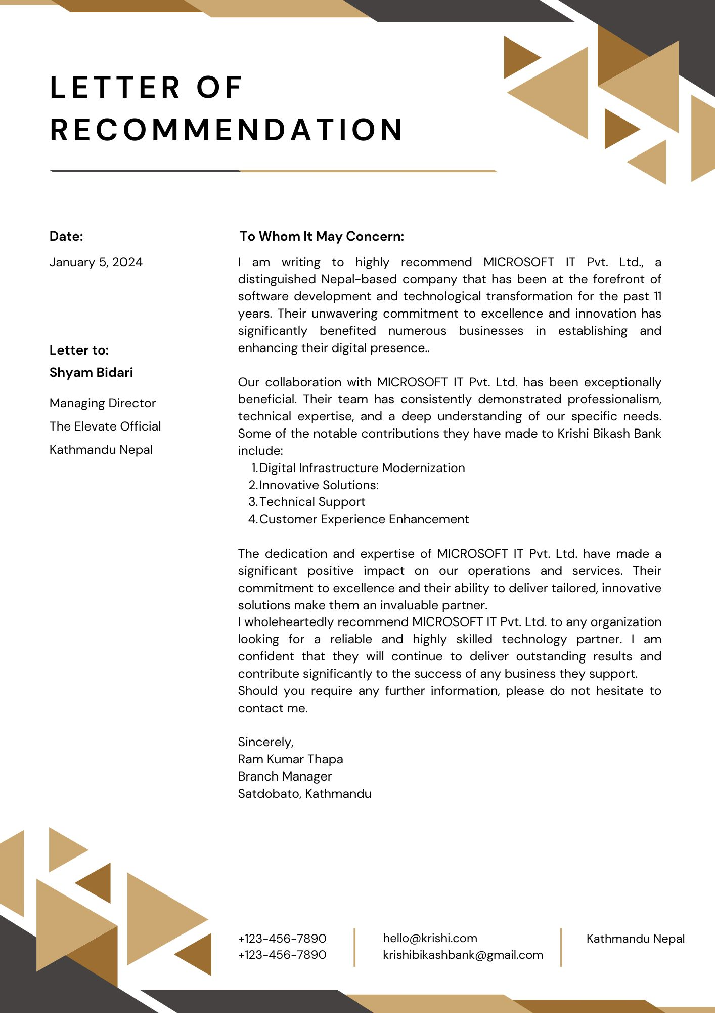

# Journal of the experience

# PROGRESS MEETINGS HELD

|  |  |  |  |
| --- | --- | --- | --- |
| **Date** | **Agenda** | **Discussions** | **Deliverables** |
| 17th April,2024 | Topic Finalization | I discuss with Saya Josi regarding assignment topic. | Grateful, Mrs. Saya josi approve the topic of assignment. |
| 22nd April, 2024 | cover letter | I Ask for suggestion on the cover latter on the assignment. | The work was approved by Mrs. Saya Josi |
| 29th April,2024 | Title page | I asked for suggestion on the title page of the assignment. | The title page was approved by Mrs. Saya Joshi |
| 3rd May, 2024 | Finalize the Assignment | I Asked about the layout of the assignment and wording in assignment. | The layout and other element were approved by the module leader.  But the suggest about the final documentation. |
| 21th May, 2024 | All the previous suggestion was improvised. | All the layout are implemented | Module leader suggest to add  Letter of recommendation.  And add journal of experience |